**LTI system proof:**

The dominant frequency pairs of input and output were extracted and have been plotted as shown in figure 1.

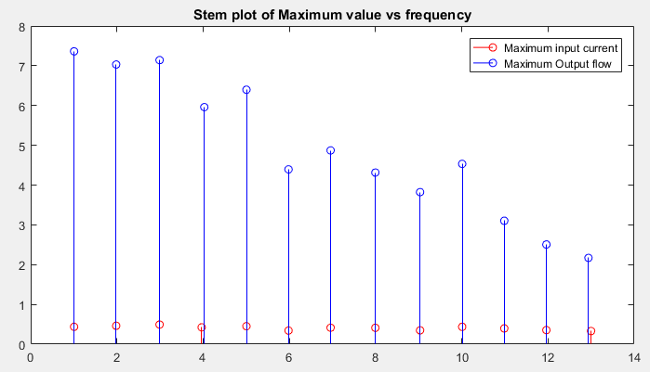

*Figure 1*

|  |  |  |  |  |
| --- | --- | --- | --- | --- |
| **Frequency (in Hertz)** | **Maxi** | **Maxo** | **Freqi** | **Freqo** |
| 1 | 0.436115 | 7.361959 | 1.00708 | 1.00708 |
| 2 | 0.462636 | 7.031206 | 1.983643 | 1.983643 |
| 3 | 0.491842 | 7.142287 | 2.990723 | 2.990723 |
| 4 | 0.423591 | 5.959857 | 3.967285 | 4.02832 |
| 5 | 0.451154 | 6.397098 | 5.004883 | 5.004883 |
| 6 | 0.342455 | 4.394513 | 5.981445 | 5.981445 |
| 7 | 0.413552 | 4.871698 | 6.958008 | 6.958008 |
| 8 | 0.411739 | 4.314304 | 7.995605 | 7.995605 |
| 9 | 0.348045 | 3.822579 | 9.033203 | 9.033203 |
| 10 | 0.436622 | 4.532579 | 10.00977 | 10.00977 |
| 11 | 0.396725 | 3.102182 | 10.98633 | 10.98633 |
| 12 | 0.35427 | 2.505756 | 11.96289 | 11.96289 |
| 13 | 0.330145 | 2.169651 | 13.00049 | 12.93945 |

As it can be seen that the frequencies of the input and the steady state output are perfectly matched for all frequencies except for very negligible offset for 4 hertz and 13 hertz. Therefore the system is a LTI system.

**System order:**

Having the dominant frequency and its corresponding maximum output value, we get Bode plot of the system. Looking at figure 2, the bode plot can be approximated as straight line and the corresponding slope of the fitted linear curve was found to be -16.75 which is close to -20. Hence the system can be approximated as first order system.

$F=F_{peak}e^{-\frac{t}{τ}}$ $P\left(s\right)=\frac{Ks}{1+τs}$ where $τ$ is time constant.

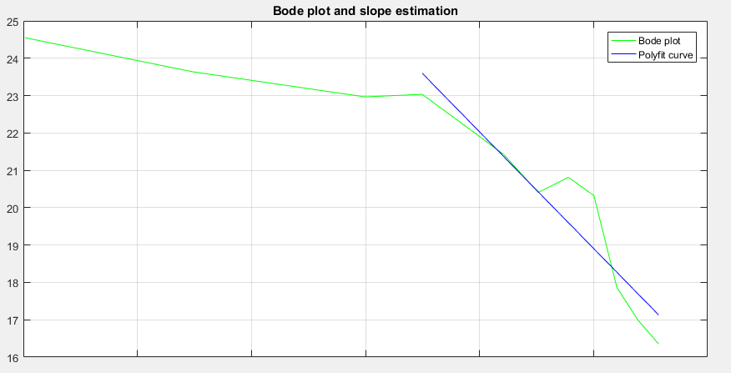

*Figure 2*

**Step response analysis:**

Step input of 2 A, 2.5A, 3A and 3.3A current is provided to the system and the corresponding flow output value is stored and plotted as shown in figure 3. As it can be observed that the on applying current, the force rises to peak value and then decays down to a very little value. This mimics the nature of decaying exponential curve which proves the previous approximation of first order system.

To calculate the plant function we need to calculate $τ$ and K:

$τ=T_{s}/4$ where $T_{s}$ is settling time

$$\lim_{t→0} Δf\left(t\right)=\lim_{s→∞} sΔF\left(s\right)=\lim_{s→∞}\frac{Ks^{2}}{(1+τs)}\frac{I_{0}}{s}$$

$\lim_{t→0} Δf\left(t\right)= \lim_{s→∞}\frac{K}{(1/s+τ)}I_{o}$

$K= I_{o}τ/ Δf\left(0\right)$

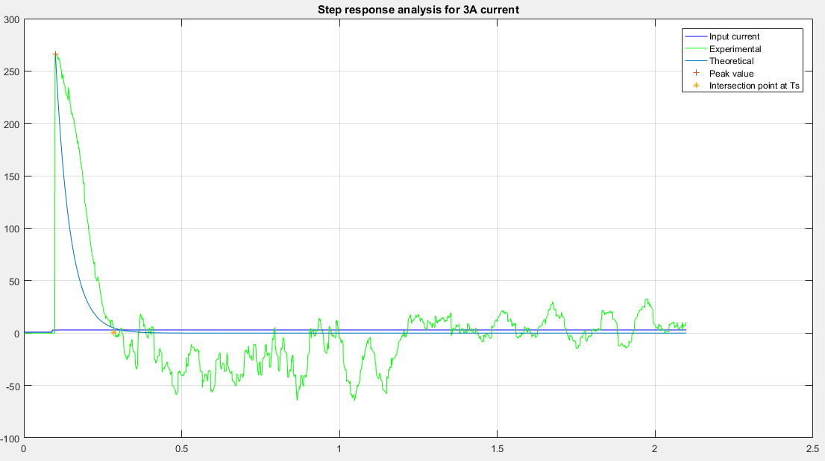

*Figure 3: Step response for 3A input*

We get the following system plant function parameters corresponding to the input current:

|  |  |  |  |  |
| --- | --- | --- | --- | --- |
| **Input current** | 2A | 2.5A | 3A | 3.3A |
| **K** | 5.809496 | 4.379561 | 4.090309 | 4.378168 |
| $$τ$$ | 0.04875 | 0.04 | 0.04625 | 0.05375 |

**Lag Compensator Design:**

Transfer function of lag compensator is $G_{c}\left(s\right)=K_{c}β\frac{T_{c}s+1}{βT_{c}s+1}$ and with the given corner frequencies as 1Hz and 5Hz, we calculate $β$ and $T_{c}$

$$2π×1Hz=1/T_{c}$$

$$2π×5Hz=1/βT_{c}$$

This gives $T_{c}=0.1592$ and $β=0.2$

Now, to determine the gain $K_{c}$ from attenuation required to bring the magnitude curve to 0 dB at frequencies above 1 Hz, we plot Bode for all the 4 system transfer function (shown in figure 4) and calculate $K_{c}$.

$$attenuation=-20\log_{10}{(K_{c})}$$

|  |  |  |  |  |
| --- | --- | --- | --- | --- |
| **Input current** | 2A | 2.5A | 3A | 3.3A |
| $K_{c}$ | 0.008393 | 0.009136 | 0.01131 | 0.012279 |

*Figure 4*

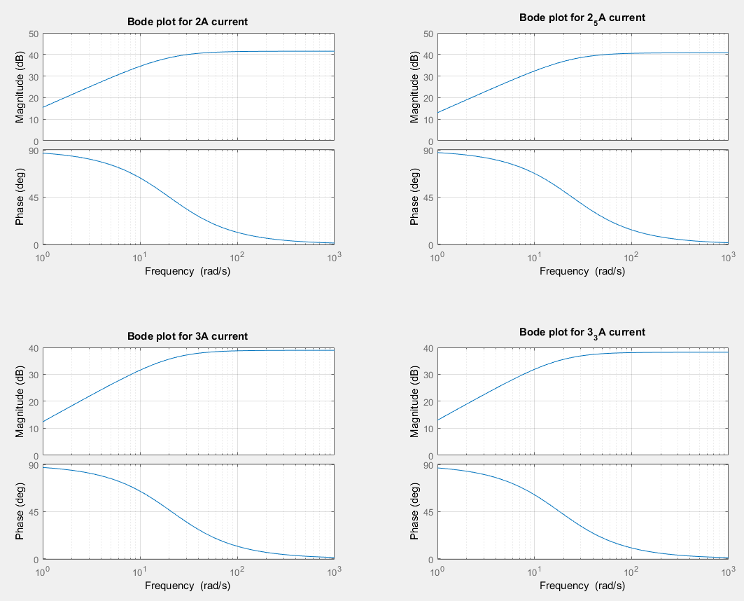

**Tuning the controller:**

Given the objective to tune the controller gain such that the controller output is less than 2.3A. We take $∆F_{d}\left(s\right)=0$, which means disturbance is the input to the system.

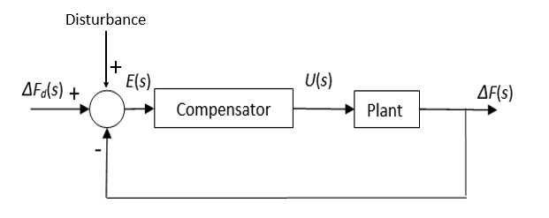

At first we generate a Disturbance signal model composed of sinusoidal (1Hz and 4 Hz), step and ramp signals of magnitude 2500 N. This Signal (shown in figure 5) is constructed by using Heaviside function in Matlab.

Now, writing the closed loop transfer function, we get:

$\frac{Y(s)}{D(s)}= \frac{P\left(s\right)U(s)}{D(s)}=\frac{C\left(s\right)P\left(s\right)}{1+C\left(s\right)P(s)} →$ $U\left(S\right)=$ $\frac{C\left(s\right)D\left(s\right)}{1+C\left(s\right)P(S)}$

Using *lsim* function in Matlab we simulate and plot U(t) for the simulated time duration. For all the 4 plant functions the value of Kc is lowered till the maximum value of U(t) reduces below 2.3A. From this we obtain the tuned controller gain and the corresponding attenuation which is given by:

$$attenuation=\frac{max(D)-max(Y)}{max(D)}×100 \%$$

|  |  |  |  |  |
| --- | --- | --- | --- | --- |
| **Input current** | 2A | 2.5A | 3A | 3.3A |
| **Kc** | 0.001268 | 0.001253 | 0.001236 | 0.001232 |
| **attenuation(%)** | 91.11822 | 92.19311 | 93.48633 | 94.81919 |

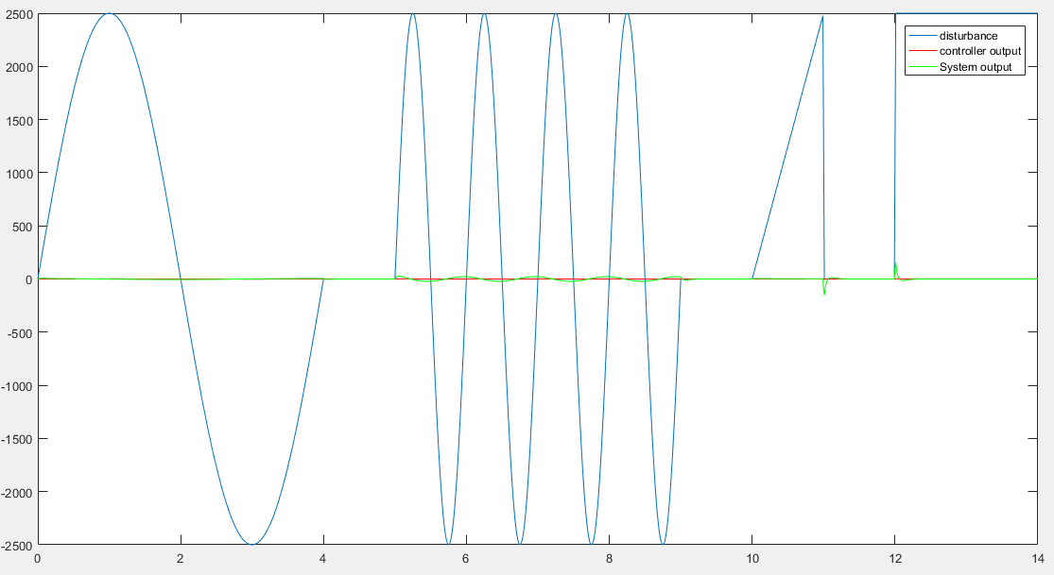

*Figure5*

it can be o

bserved tha

t the controller

o

utput

lies below 2.3

A and th

e force

variation

out

put

is

considerably lowered

it can be o

bserved tha

t the controller

o

utput

lies below 2.3

A and th

e force

variation

out

put

is

considerably lowered

It can be seen that the controller output lies below 2.3 A and the force variation output is considerably lowered and the process of lowering the gain was carried out for all four compensators. So the corresponding compensator produced the best results with all plant transfer functions is given by

$$C\left(s\right)=\frac{3.923e-05 s + 0.0002465}{0.03183 s + 1}$$

$$G\left(s\right)=\frac{0.0001717 s^2 + 0.001079 s}{0.001711 s^2 + 0.08558 s + 1}$$

The designed lag compensator performed well and was able to lower the force disturbances by 94.81%.